
Using Your LCD Keypad Shield

Overview:
This tutorial demonstrates how to use an LCD keypad shield and determine the correct voltage offsets to use for the keypad buttons.
Materials:
This project requires an Arduino UNO (or compatible board), an LCD keypad shield, eight female/male jumper wires, and a computer with the Arduino IDE installed with a USB connector for the UNO.
Procedure:
1: Either wire together the UNO and LCD keypad shield according to figure 1, or directly attach the LCD keypad shield on top of the UNO.

fig. 1
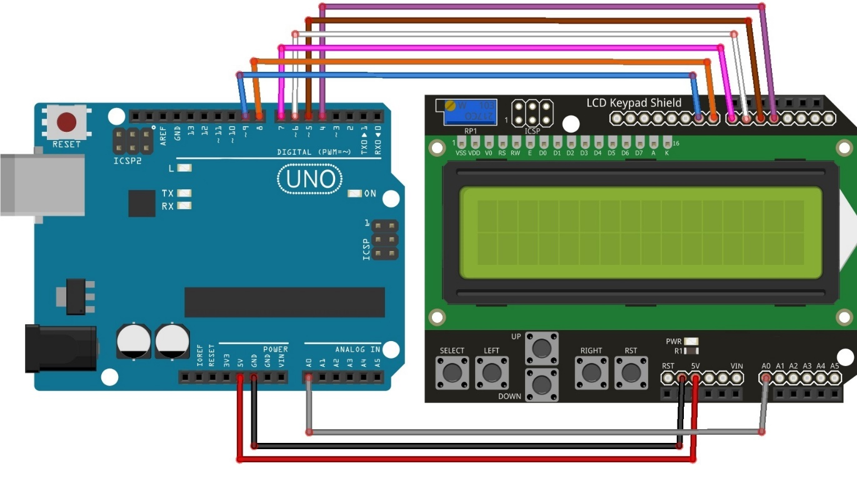

2: Go to www.rabbitrobots.com and download the LCD keypad test program from the “Software” section.
3: Open the downloaded LCDKeypadTest.ino file with the Arduino IDE and upload it to the UNO.
4: Press the left, right, up, down and select keys on the keypad to see if they display on the LCD screen. If any of the buttons don’t properly register when pressed, go to the “Adjusting Voltage Ranges” section at the end of this document.
5: Read the analog output value from the shield on the bottom of the LCD screen.
6: See what happens when multiple buttons are pressed.

Code explanation
The first section of the code (fig.2) imports the libraries needed to use the LCD screen, define the program’s constants, declare variables used by the program, and declares the actual LCD screen itself. The very first line “#include <LiquidCrystal.h>” imports all of the functions the program needs in order to be able to use the LCD screen. The LCD screen wouldn’t be reasonably usable without this.

The section below that line defines all of the constant the program is going to use with #define. The text after #define is the name of the constant, and value that it represents. Since each of these have a name and a value, it seems that these constants should be variables, but they are actually “macros” because of how they are handled by the compiler. However, for the purposes of this program, they will be treated as numerical constants

The first set of constants represent the different keys that could be pressed on the LCD keypad, minus the reset button. It’s important to note that there is a constant keyNone since it is important to know when there is no key being pressed as well. There are also constants lcdRows and lcdCols. These represent the number of rows and columns of characters on the LCD screen, and while most LCD screens are 2x16, these constants can be changed for larger displays.

The line “LiquidCrystal lcd(8, 9, 4, 5, 6, 7);” declares the LCD display itself in the program. The numbers match up to the rs, enable, and four digital data pins on the LCD display. The rs pin is what handles when to send data to the LCD screen, the enable pin actually enables and turns on the LCD screen and the four digital data pins carry data to the LCD to be displayed.
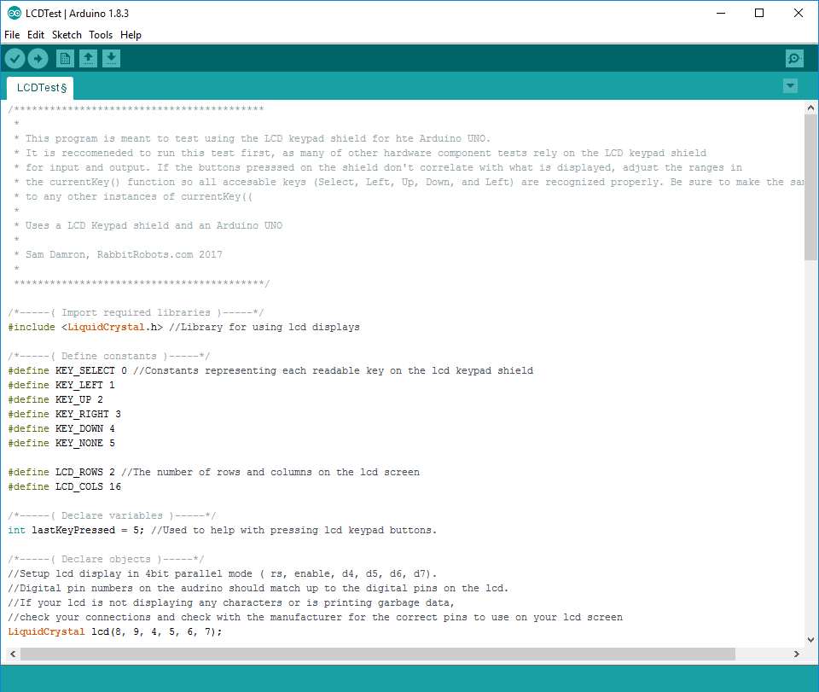
fig. 2

The next section of the code is the setup() function (fig. 3) that runs once when the UNO starts. There’s only one line of code in this section, ”lcd.begin(lcdRows, lcdCols);.” This line of code tells the UNO to start using the LCD display with the number of rows and columns defined earlier.
fig. 3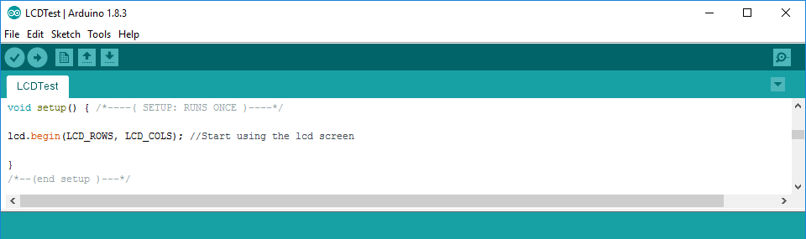
The section after this is the loop() function (fig. 4). This function starts once setup()is finished and runs continuously for the rest of the program. This is generally where all the main functions of the program are executed. The first line of this method, “lcd.setCursor(0, 0);” sets the cursor in the upper-left corner of the LCD display at coordinate (0, 0). Locations on computer screens are represented by a coordinate system with the column number as the first coordinate and the row number as the second. In addition, the coordinates start at zero instead of one. Computers generally start counting from zero instead of one, so the screen coordinates start at zero as well.
The next line sets the value of variable keyPressed to the value representing the current key being held down with the currentKey()function. This function returns what key is being pressed by reading the analog output coming from the LCD Keypad Shield’s analog port 0. A more in-depth explanation of how this function works can be found in the “Adjusting Voltage Ranges” section at the end of this document.
The set of else-if statements check two things, the current button being pressed, and if the current button being pressed has changed. It does this first by comparing keyPressed to the key-related constants defined earlier to see if they match. Then, it checks if the current key being pressed is the same key that was pressed last time in the loop (lastKeyPressed). If the key isn’t the same one, the if-statement will run.
Within each if-statement, two things are done, printing what key was pressed to the LCD screen and updating lastKeyPressed to the key that was just pressed. With the print statements, most of the messages have extra spaces or “whitespace” after them. The reason for this is that the LCD screen does not know to update the whole row of characters when we print a new message. It only updates the characters contained in the message to be printed, so characters from another message can still be displayed even after they are no longer needed. The whitespace in the message forces the characters after the message to be changed to a blank, avoiding garbled messages.
Lastly, The final section of loop()prints out the voltage data from the LCD keypad shield to the LCD screen. The third line, “LCD.print(analogRead(0));” is unique in this program in that it is the only time non-text data is printed on the LCD screen. Any type of simple, or “primitive” data such as numbers, characters, text, or Booleans (true/false statements) can be displayed on the LCD screen in some form.
fig. 4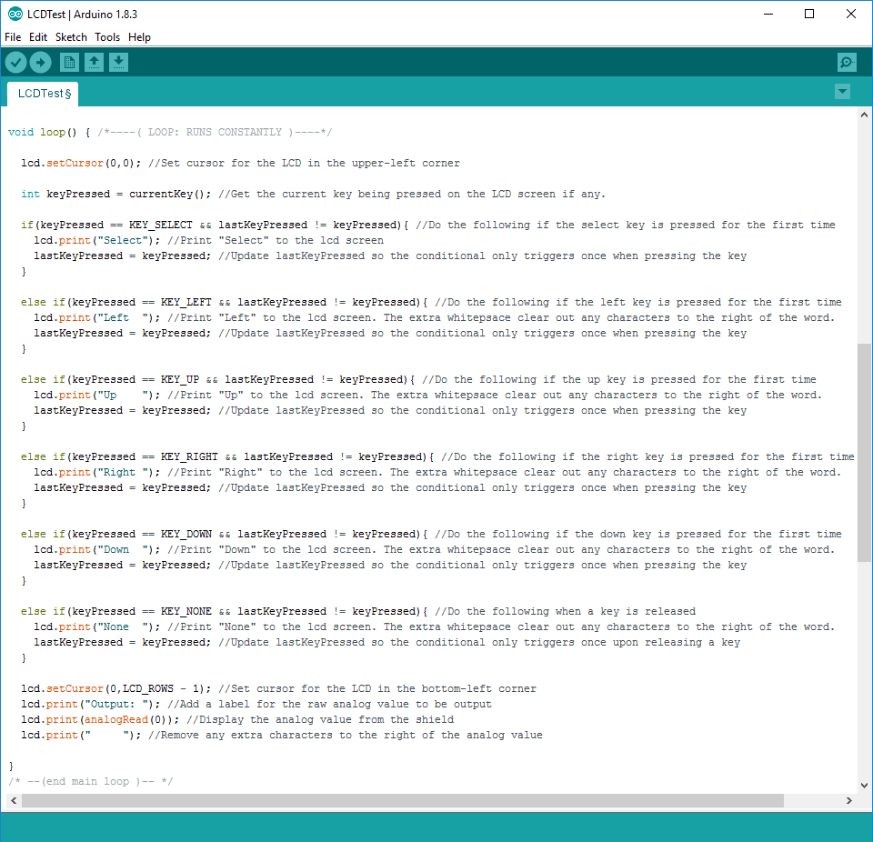

Adjusting Voltage Ranges
This section demonstrates how to adjust the program if the keys do not read correctly on your LCD screen. The keypad buttons are handled in the LCDTest program by the function currentKey()which simply returns a key constant depending on what voltage is applied to the UNO’s analog pin 0 from the LCD keypad shield in units of .0049V. Any changes made to this function will have to be made to any other programs with this function to make them work as well.
1: Hold down each key on the LCD keypad shield once and write down the value displayed as “Output” for each of them.
2: Open the LCDTest.into file and scroll down to the currentKey() function (fig. 5).
fig. 5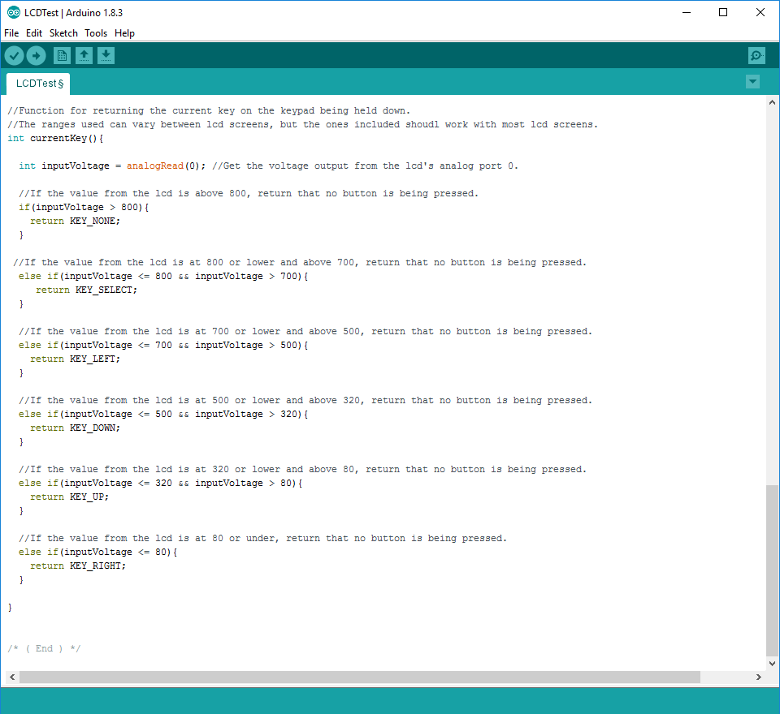
3: Re-order the return statements so the key with the highest output voltage is first and the key with the lowest output voltage is last in the else-if block.
4: Change the first if-statement to “if(inputVoltage > A)” with A being the highest output voltage written down plus 20.
5: Change the following else-if statement to “else if(inputVoltage <= A && inputVoltage > B)” with B being the second highest output voltage minus 20.
6: Change the second else-if statement to “else if(inputVoltage <= B && inputVoltage > C)” with C being the third highest output voltage minus 20.
7: Change the third else-if statement to “else if(inputVoltage <= C && inputVoltage > D)” with D being the fourth highest output voltage minus 20.
8: Change the fourth else-if statement to “else if(inputVoltage <= D && inputVoltage > E)” with E being the lowest output voltage minus 20.
9: Change the last else-if statement to “else if(inputVoltage <= E)“

